

**INTERNATIONAL SCHOOL**

**CAPSTONE PROJECT 1**

**CMU-CS 246**

**USER INTERFACE DESIGN DOCUMENT**

Version: 1.0

**CALCULATOR SYSTEM – CS**

**Mentor: Nguyen Dang Quang Huy**

***Team Member*:**

Hue, Nguyen Thi Kim

Hieu, Vo Trung

Quang, Truong Minh

Hoang, Tran Dinh Huy

Huyen, Phan Thi Thanh

**Approved by Huy Nguyen Dang Quang**

**UserInterface Review Panel Representative:**

Name Signature Date

**Capstone Project 1- Mentor:**

Name Signature Date

Da Nang, 01/2024

**PROJECT INFORMATION**

| **Project Acronym** | CS |
| --- | --- |
| **Project Title** | Calculator System | | | |
| **Start Date** | 23 – Jan – 2024 | **End Date** | 23 – Jan –2024 | |
| **Lead Institution** | International School, Duy Tan University | | | |
| **Team Member** | **Name** | **Email** | | **Phone** |
| 28201154111 | Nguyen Thi Kim Hue | nguyenthikimhue30072004@gmail.com | | 0763130637 |
| 28219050216 | Vo Trung Hieu | [trunghieu0981633043@gmail.com](mailto:trunghieu0981633043@gmail.com) | | 0981633043 |
| 28211101410 | Truong Minh Quang | quangff296@gmail.com | | 0835650230 |
| 28218006519 | Tran Dinh Huy Hoang | [htrandinh204@gmail.com](mailto:htrandinh204@gmail.com) | | 0934774160 |
| 28209054134 | Phan Thi Thanh Huyen | phanthithanhhuyen2k4@gmail.com | | 0917810012 |

**PROJECT PLAN DOCUMENT**

| **Document Title** | User Interface Document | | |
| --- | --- | --- | --- |
| **Author(s)** | Team 4 | | |
| **Date** | Jan 23th, 2024 | **File name:** | USER INTERFACE DESIGN DOCUMENT.docx |
| **URL** | [CMU-CS 246 DIS-TEAM 4 - Google Drive](https://drive.google.com/drive/folders/1zZsyqwJ_dQ9k3gFQZejZngDM12EJcCbc) | | |
| **Access** | Project and CMU Program | | |

**SIGNATURE**

**Document Approvals:** The following signatures are required for approval of this document.

| **Mentor** | Huy, Nguyen Dang Quang | **Signature:** |  |
| --- | --- | --- | --- |
| **Date:** |  |
| **Scrum master** | Hue, Nguyen Thi Kim | **Signature:** |  |
| **Date:** |  |
| **Team member(s)** | Hieu, Vo Trung | **Signature:** |  |
| **Date:** |  |
| Quang, Minh Truong | **Signature:** |  |
| **Date:** |  |
| Hoang, Tran Dinh Huy | **Signature:** |  |
| **Date:** |  |
| Huyen, Phan Thi Thanh | **Signature:** |  |
| **Date:** |  |

**DOCUMENT HISTORY**

| **Version** | **Person** | **Date** | **Description** |
| --- | --- | --- | --- |
| 1.0 | Nguyen Thi Kim Hue | Jan 23th, 2024 | Final |

**Contents**

**I.** **INTRODUCTION 6**

1. PURPOSE 6

2. SCOPE 6

3. SCOPE 6

**I.** **LIST OF USER INTERFACE 7**

1. BUSINESS FUNCTION DIAGRAM: 7

2. WEB APP: 8

**II.** **DESCRIBE USER INTERFACE 8**

1. HOME PAGE 8

2. ADDITION PAGE 10

3. SUBTRACTION PAGE 11

4. MULTIPLICATION PAGE 12

5. DIVISION PAGE 14

6. MOD PAGE 15

# INTRODUCTION

## PURPOSE

* Document the design of user interface of functions of the Calculator System
* Be the primary document driving the implementation of the user interfaces.
* Introduce interface design for the reader. Including the background, content information display, command buttons.

## SCOPE

* This document helps to better understand the interface of the System, detailed specification components and function of the System.
* With this document, the development team can understand the structure and composition to create a consistent and complete system.
* Overview of the stages and modules of the software and create a complete interface.

## SCOPE

This document is intended for the following audiences:

* Project Manager
* Requirements Manager
* Architect
* Support Team
* Implementers, including:
  + Developers.
  + Testers.

# LIST OF USER INTERFACE

## BUSINESS FUNCTION DIAGRAM:

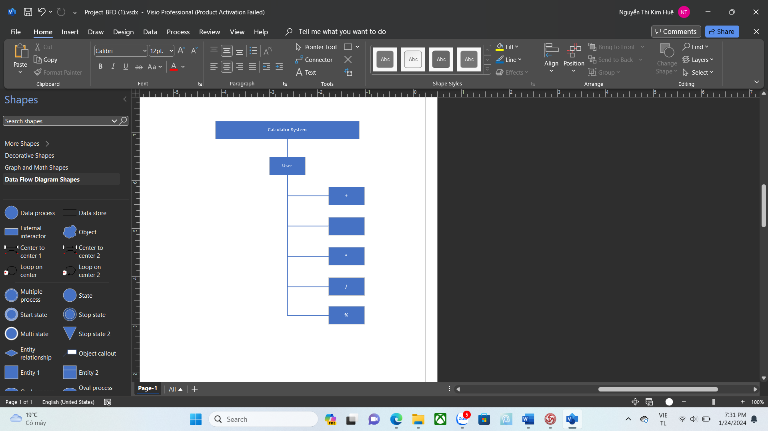

*Figure 1: Business Function diagram*

## WEB APP:

| **User Interface ID** | **UI Name** | **Description** |
| --- | --- | --- |
| UI-01 | Home Page | Home page allows users to select the calculation they want to perform |
| UI-02 | Addition Page | This page is for user to perform addition calculations |
| UI-03 | Subtraction Page | This page is for user to perform subtraction calculations |
| UI-04 | Multiplication Page | This page is for user to perform multiplication calculations |
| UI-05 | Division Page | This page is for user to perform division calculations |
| UI-06 | Mode Page | This page is for user to perform mode calculations |

*Table 1: List of Interface*

# DESCRIBE USER INTERFACE

## HOME PAGE

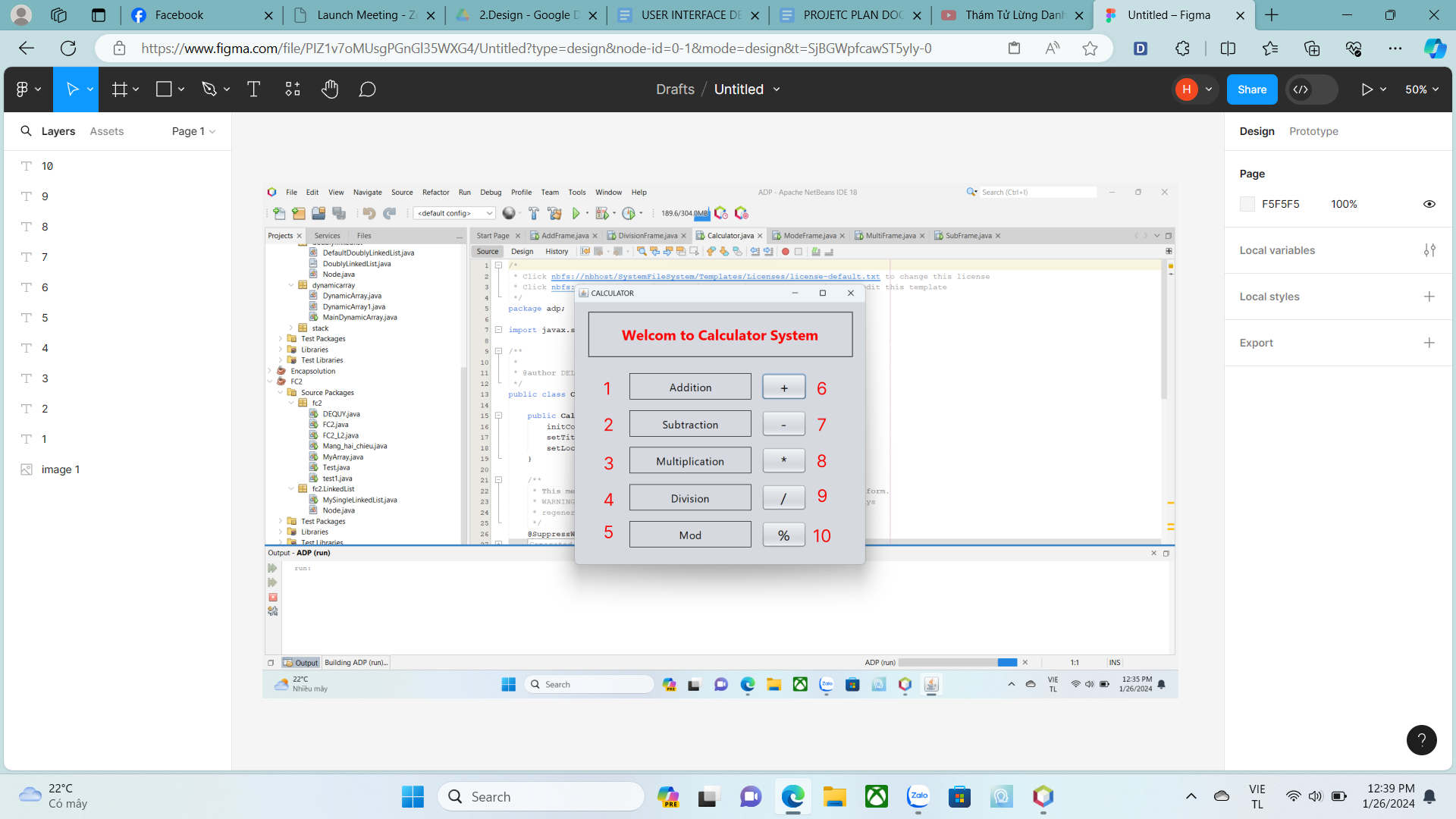

| **ID** | **Condition** | **Control Type** | **Target** |
| --- | --- | --- | --- |
| 1 |  | Label | Addition |
| 2 |  | Label | Subtraction |
| 3 |  | Label | Multiplication |
| 4 |  | Label | Division |
| 5 |  | Label | Mode |
| 6 | Press | Button | Click to go to the Addition page |
| 7 | Press | Button | Click to go to the Subtraction page |
| 8 | Press | Button | Click to go to the Multiplication page |
| 9 | Press | Button | Click to go to the Division page |
| 10 | Press | Button | Click to go to the Mode page |

*Table 2: Describe User Interface Homepage*

## ADDITION PAGE

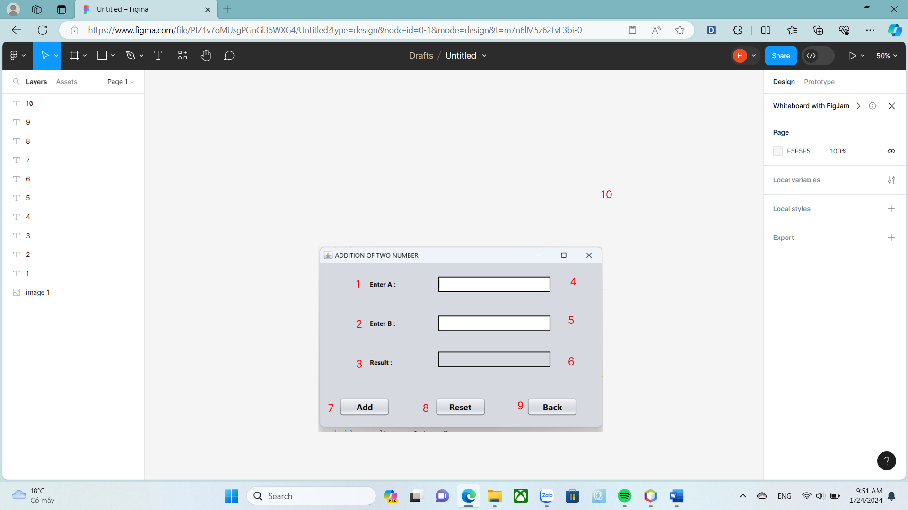

| **ID** | **Condition** | **Control Type** | **Target** |
| --- | --- | --- | --- |
| 1 |  | Label | Enter A |
| 2 |  | Label | Enter B |
| 3 |  | Label | Result |
| 4 | Enter a number | Text field | Gets the value of a number used for calculation |
| 5 | Enter a number | Text field | Gets the value of a number used for calculation |
| 6 |  | Label | Displays the results of the calculation |
| 7 | Press | Button | Click to view the results of the addition calculation |
| 8 | Press | Button | Click to reset all text fields |
| 9 | Press | Button | Click to returns to homepage |

*Table 3 : Describe User Interface Addition page*

## SUBTRACTION PAGE

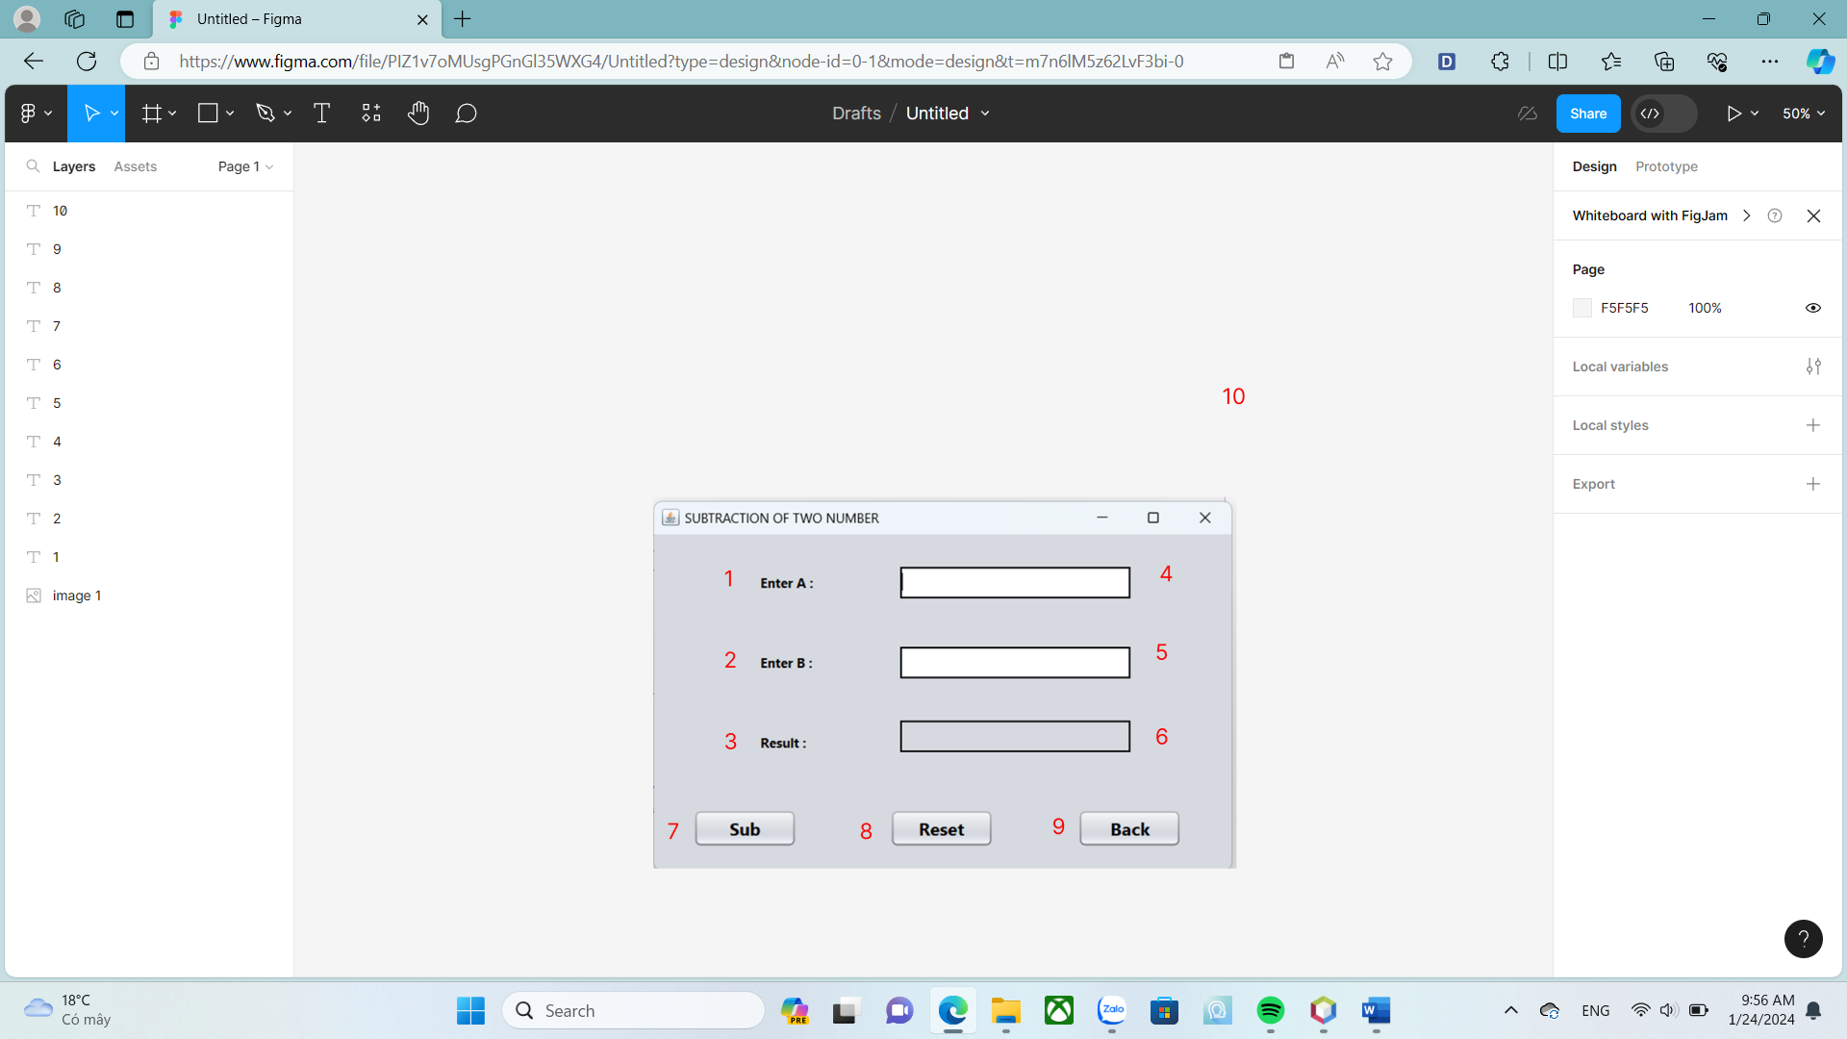

| **ID** | **Condition** | **Control Type** | **Target** |
| --- | --- | --- | --- |
| 1 |  | Label | Enter A |
| 2 |  | Label | Enter B |
| 3 |  | Label | Result |
| 4 | Enter a number | Text field | Gets the value of a number used for calculation |
| 5 | Enter a number | Text field | Gets the value of a number used for calculation |
| 6 |  | Label | Displays the results of the calculation |
| 7 | Press | Button | Click to view the results of the subtraction calculation |
| 8 | Press | Button | Click to reset all text fields |
| 9 | Press | Button | Click to returns to homepage |

*Table 4 : Describe User Interface Subtraction page*

## MULTIPLICATION PAGE

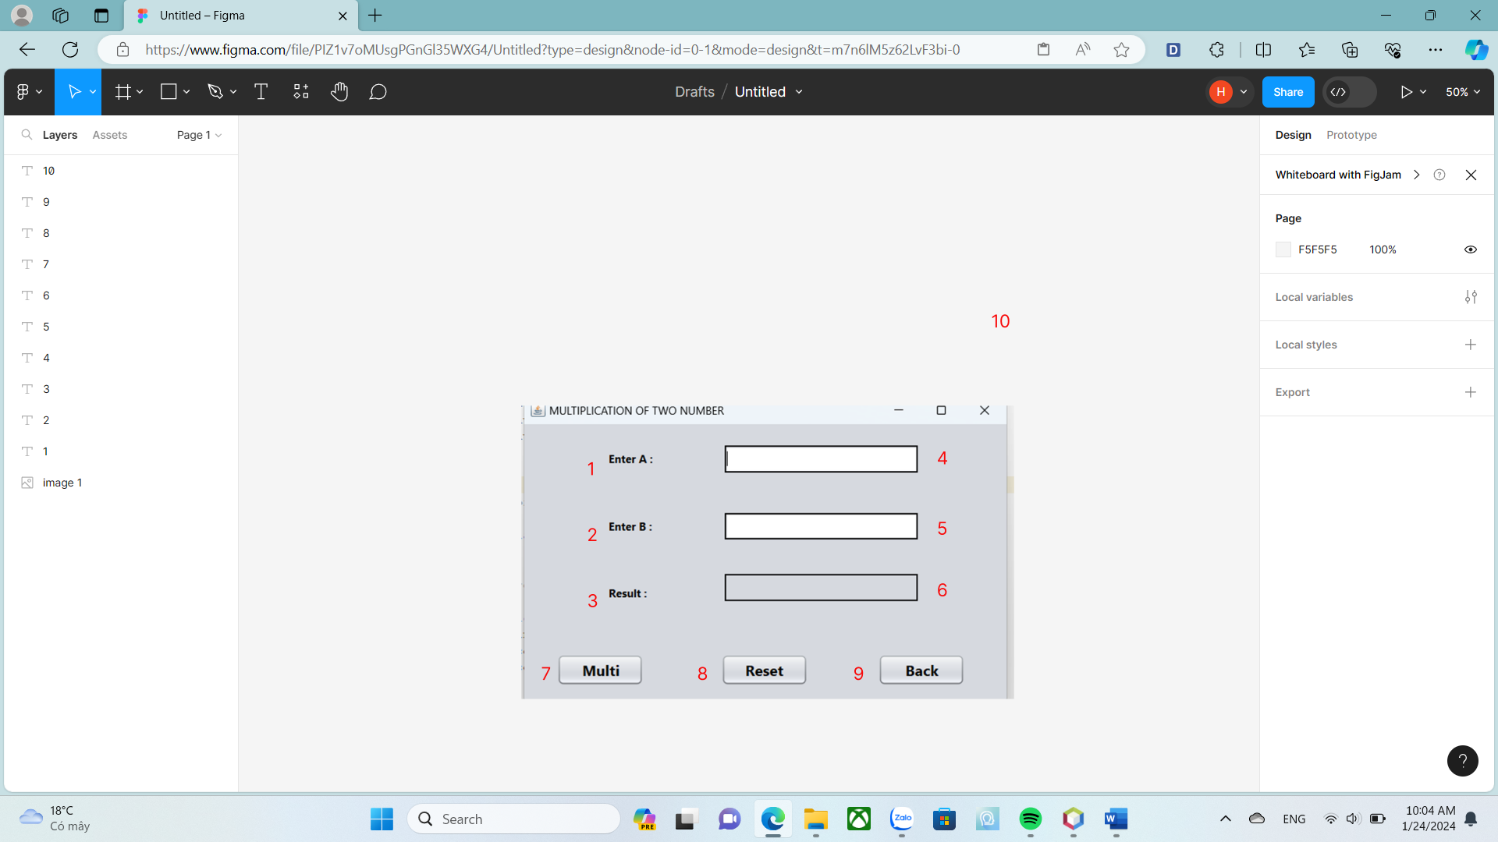

| **ID** | **Condition** | **Control Type** | **Target** |
| --- | --- | --- | --- |
| 1 |  | Label | Enter A |
| 2 |  | Label | Enter B |
| 3 |  | Label | Result |
| 4 | Enter a number | Text field | Gets the value of a number used for calculation |
| 5 | Enter a number | Text field | Gets the value of a number used for calculation |
| 6 |  | Label | Displays the results of the calculation |
| 7 | Press | Button | Click to view the results of the multiplication calculation |
| 8 | Press | Button | Click to reset all text fields |
| 9 | Press | Button | Click to returns to homepage |

*Table 5 : Describe User Interface Multiplication page*

## DIVISION PAGE

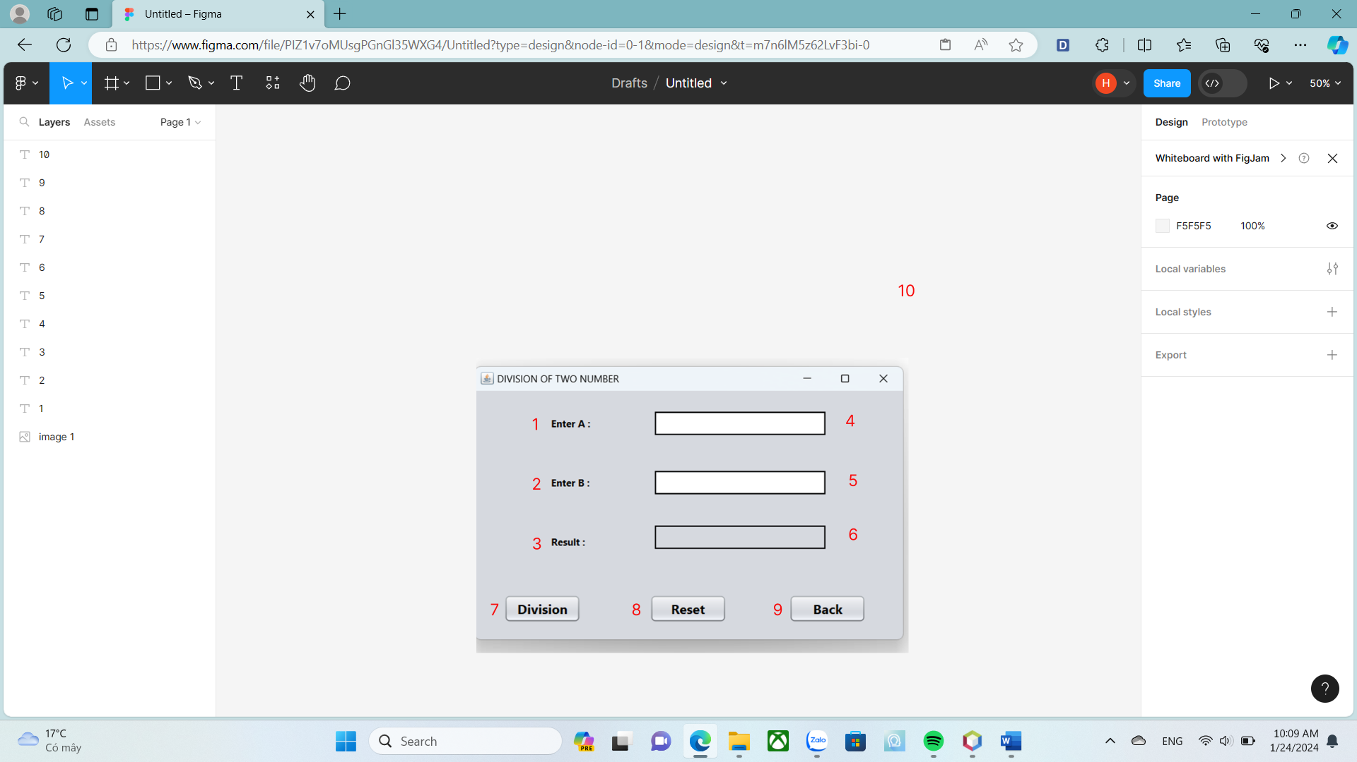

| **ID** | **Condition** | **Control Type** | **Target** |
| --- | --- | --- | --- |
| 1 |  | Label | Enter A |
| 2 |  | Label | Enter B |
| 3 |  | Label | Result |
| 4 | Enter a number | Text field | Gets the value of a number used for calculation |
| 5 | Enter a number | Text field | Gets the value of a number used for calculation |
| 6 |  | Label | Displays the results of the calculation |
| 7 | Press | Button | Click to view the results of the division calculation |
| 8 | Press | Button | Click to reset all text fields |
| 9 | Press | Button | Click to returns to homepage |

*Table 6 : Describe User Interface Division page*

## MOD PAGE

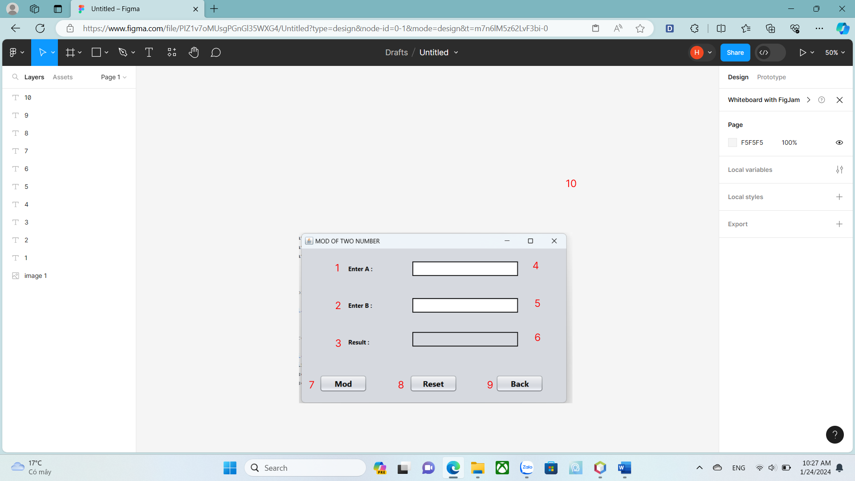

| **ID** | **Condition** | **Control Type** | **Target** |
| --- | --- | --- | --- |
| 1 |  | Label | Enter A |
| 2 |  | Label | Enter B |
| 3 |  | Label | Result |
| 4 | Enter a number | Text field | Gets the value of a number used for calculation |
| 5 | Enter a number | Text field | Gets the value of a number used for calculation |
| 6 |  | Label | Displays the results of the calculation |
| 7 | Press | Button | Click to view the results of the mod calculation |
| 8 | Press | Button | Click to reset all text fields |
| 9 | Press | Button | Click to returns to homepage |

*Table 7 : Describe User Interface Mod page*